RFID Reader and Access Cards
Vender: Jedrek
http://www.jedreksys.com/product/RFID-125kHz-ID-card-reader-Embedded-module-Circuit-Modules-UART-Interface.html
Data Sheet 1
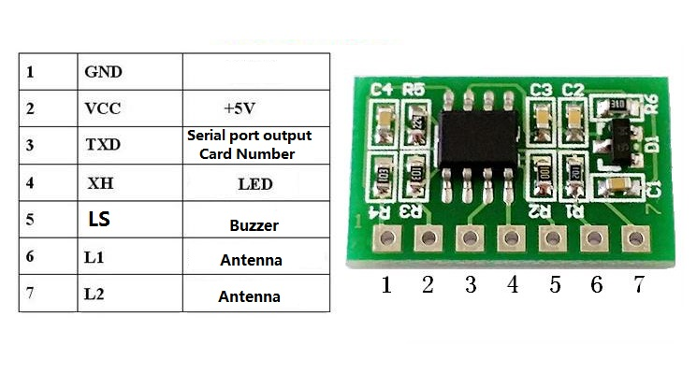
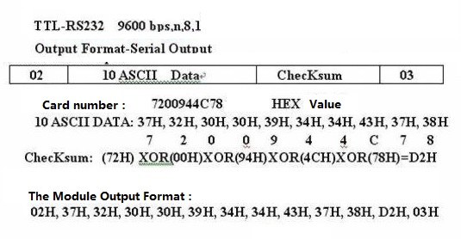
RFID card reader module can read the EM4100 125K series (or compatible) RFID card. The module is very convenient to use, connected to the supporting read card antenna (coil) serial connecting one of the microcontroller, power supply is switched on. When RFID card into the card reader range module automatically to card through serial (UART) to send out, MCU receives can control relay to realize simple access.
Power supply: 5V,
Operating frequency: 125khz+-1khz
Support card: EM4101/4100 or compatible card
Reading distance:<7CM
Output mode: serial TTL- 232 level
Card: a card brush card output
Card reading speed:<100MS
Working temperature: -10-75 C
Size: 2 x 1.2cm
Coil size: 345uH
Coil size: 50 * 70mm
Out Data format:
serial port: 9600bps, n ,8 ,1
Out Foemat-Serial Output
02 10ASCII Data Checksum 03
02 is head; 03 is End number
Package include
1× RFID 125kHz ID card reader Embedded module Circuit Modules UART Interface

App note
https://www.aliexpress.com/item/32702090149.html?spm=a2g0o.detail.0.0.6eb0a381LXAWEG&gps-id=pcDetailBottomMoreThisSeller&scm=1007.13339.169870.0&scm_id=1007.13339.169870.0&scm-url=1007.13339.169870.0&pvid=5fdef783-fd81-4682-bbfb-88597a244233&_t=gps-id:pcDetailBottomMoreThisSeller,scm-url:1007.13339.169870.0,pvid:5fdef783-fd81-4682-bbfb-88597a244233,tpp_buckets:668%230%23131923%2391_668%23888%233325%2310_668%232846%238109%231935_668%232717%237562%23494_668%231000022185%231000066058%230_668%233468%2315609%23220

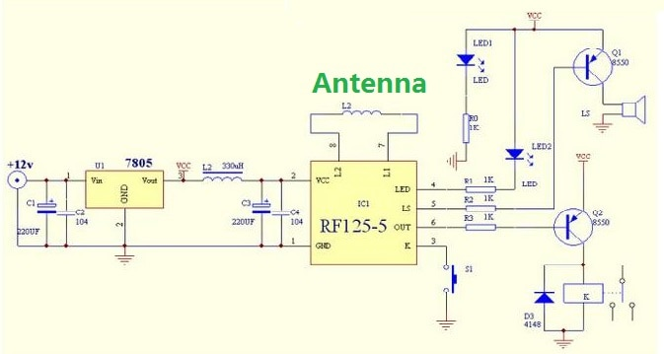
Data Sheet 2
1,GND
2,VCC, 5V
3,K, Setup Key
4,Led
5,LS, beep sound out
6,Out, Switch Signal Output
7,L1, antenna
8,L2, antenna

This module is a multi-functional intelligent card reader control module. It has far exceeded the function of “reading card module”. It is characterized by intelligent devices and RF circuits. It has 4 functions: RF-sensitive card reading + card issuing and Registration management + identification and auditing + control output. Since the intelligent module and the user card use the two-way authentication mechanism, the card that is not registered by the management card into the intelligent module is a non-transmitted user card, and cannot enter at all, so the intelligent module Security and confidentiality are quite good. This module is a safe, reliable, low-cost, and easy-to-use intelligent module. It requires almost no secondary development and requires only a small number of external devices to form a practical system. Users and developers do not need to understand RF identification technology, just understand the basic pin function of this module, that is, can quickly develop and mass produce ultra-low-cost, finished applications of various applications with RF card management and control functions. This module can also be embedded in its existing equipment for easy RF management and control.
Typical application case
RF induction lock, electric lock control, such as security door, password box, safe, etc.;
Can assemble the access control system, personnel, vehicle access control, etc.; ^
Equipment management of home or business, such as public self-service equipment, identity control of elevator users, electric cabinets, electrical appliances, etc., where power is limited. ^
Any other device that requires identification and control.
Operating voltage: 5V, current: <50mA
Support card type: 125KHZ EM001/4102 or compatible EMID card
Card reading distance <100mm, reading card time <0. 5 seconds
management card and 50 user cards can be set^
When the authorized user card is authorized, the switch signal output, drive the load or relay, such as the lock electrical switch, etc.;

Swipe Cards
https://www.priority1design.com.au/em4100_protocol.html
EM4100 Protocol description.
RFID transponders (Tags) are devices carrying digital information that can be read from a distance by a
RFID transceiver (Reader). In order to be able to read the information stored on the RFID tags the reader
must know how the information is stored and the protocol for extracting it. One of the more common data
formats for RFID transponders is the EM4100 protocol, named so because the microchip at the heart of
the Tag is based on the controller chip made by the company EM Microelectronic.
Reading an EM4100 RFID Transponder.
EM4100 compatible RFID transponders carry 64 bits of Read Only memory. This means that information
can be read from the Tag but no data can be changed, or new data written to the card once the card has
been programmed with the initial data. The format of the data is as shown here.
1 | 1 | 1 | 1 | 1 | 1 | 1 | 1 | 1 | 9 bit header bits, all 1's
8 bit version number |  |  |  | D00 | D01 | D02 | D03 | P0
or customer ID. |  |  |  | D04 | D05 | D06 | D07 | P1
 |  |  |  | D08 | D09 | D10 | D11 | P2 | Each group of 4 bits
 |  |  |  | D12 | D13 | D14 | D15 | P3 | is followed by an Even
32 Data Bits |  |  |  | D16 | D17 | D18 | D19 | P4 | parity bit
 |  |  |  | D20 | D21 | D22 | D23 | P5
 |  |  |  | D24 | D25 | D26 | D27 | P6
 |  |  |  | D28 | D29 | D30 | D31 | P7
 |  |  |  | D32 | D33 | D34 | D35 | P8
 |  |  |  | D36 | D37 | D38 | D39 | P9
4 column Parity bits |  |  |  | PC0 | PC1 | PC2 | PC3 | S0 | 1 stop bit (0)
When the Tag enters the electromagnetic field transmitted by the RFID reader it draws power from the field
and will commence transmitting its data as shown above. The first 9 bits are a logic 1. These bits are used as
a marker sequence to indicate the beginning of the string. As Even parity is used throughout the data this 9 bit
sequence of 1's will not occur at any other location in the string. This is followed by 10 groups of 4 data and 1
even parity bits. Finally there are 4 bits of column parity (Even) and a stop bit (0). The Tag then continues to
repeat this string as long as it has power.
Shown here is an example string for a proximity card that has the data $06 (version number), and $001259E3
as a data string.
1 | 1 | 1 | 1 | 1 | 1 | 1 | 1 | 1 | 0 | 0 | 0 | 0 | 0 | 0 | 1 | 1 | 0 | 0 | 0 | 0 | 0 | 0 | 0 | 0 | 0 | 0 | 0 | 0 | 0 | 0 | 0 | 1 | 1 | 0 | 0 | 1 | 0 | 1 | 0 | 1 | 0 | 1 | 0 | 1 | 0 | 0 | 1 | 0 | 1 | 1 | 1 | 0 | 1 | 0 | 0 | 1 | 1 | 0 | 0 | 1 | 0 | 00
 |  |  |  |  |  |  |  |  | 0 |  |  |  |  | 6 |  |  |  |  | 0 |  |  |  |  | 0 |  |  |  |  | 1 |  |  |  |  | 2 |  |  |  |  | 5 |  |  |  |  | 9 |  |  |  |  | E |  |  |  |  | 3

