HILDI CNC With Fusion 360

Introduction 2
Machine Definition 2
Tool Library 2
Modelling 3
Setup 3
Operations 4
Simulate 4
Post Process 4
Setup Sheet 5
HILDI Operation 6
Power On 6
Load Program 6
Enable Motion 6
Home all Axis 6
Set the G54 Work Offset 6
Set the Tool Offsets 7
Run the Program 7
Clean-up 8
Appendix A – How to load and unload a tool 8
Appendix B – How to Jog 8
Appendix C – Linux CNC G/M-Code Reference 8

Introduction
This guide will help you to use Fusion 360 to build a toolpath and then use it in HILDI.

Fusion 360
This section provides guidance on how to setup Fusion 360 to create a toolpath for HILDI.

HILDI Post Processor
There is a dedicated post processor that can be download from https://github.com/HSBNE/HILDI /fusion360/emc-hildi.cps. Import this file into the Post library in Fusion 360.

Machine Definition
This are the details for creating the HILDI machine in the machine library.
General:
- Vendor: HSBNE
- Model: HILDI
- Description: Generic 3-axis
Capabilities:
- Milling
- Tool Changer:
  - Automatic Tool Changer: False
  - Supports tool preload: False
  - Number of tools: 100
- Motion:
  - Max Feedrate: 2000 mm/mmin
  - Max block processing speed: 0
Kinematics:
- X/Y/Z/Table all left at defaults.
- Head:
  - Maximum speed: 3000rpm
- Coolant: Only Flood selected
- Orientation: Along Z
Post Processing:
- Post: HILDI Enhanced Machine Controller (EMC)
Additional settings:
- Feedrate ratio (%): 100
- Tool change time: 60 s
Alternatively: this can be imported from https://github.com/HSBNE/HILDI /fusion360/HILDI.mch

Tool Library
Create tools as necessary.
Use tool numbers as per:
Tool Number | Usage
1 | Touch probe, do not use in CNC programs
2 | Face Mill
3 | End Mill 1
4 | End Mill 2
5 | End Mill 3
6 | End Mill 4
7 | Spot Drill
8 | Chamfer
9 | Drill 1
10 | Drill 2
11 | Drill 3
12 | Drill 4
13
14

Tools 1 and 2 must be as shown. The rest can be your custom tools as appropriate.
For each tool these settings can be useful:
- Fill all fields in the Cutter tab
- Holder: BT40-B4C3-0032
- Set speed and federate as appropriate.
- Set the tool number as per the Post Processor tab
  - Don’t set the Manual tool change option as this only applies to machines with automatic tool changers.

Modelling
- Model the object. It is best if this is orientated as if it will be on the table, but this can be changed in the setup.
- Model the stock over the main model, positioning the model in the appropriate spot.
- Model the fixture; either the hold-down clamps or the vice jaws.

Setup
Create a new Setup:
- Machine
  - Select the HILDI machine
- Setup
  - Operation Type: Milling
- Work Coordinate System (WCS)
  - Orientation: Model orientation. This is where you can change the orientation of the model in the machine.
  - Origin/stock point: This is the touch off point of the stock. Move it to a suitable point.
- Model
  - Choose the main model
- Fixture: Enabled
  - Fixture: Choose whatever the modelled fixture points are (hold-down clamps or vice jaws).
Stock:
- Stock
  - Mode: From Solid
  - Stock Solid: choose the stock model
- Stock Dimensions:
  - Check that these look right.
  - Ensure that the stock is modelled correctly, otherwise you may have a rapid collision!
Part Position:
- Position the part in the stock as appropriate.
Post Process:
- The machine WSC should be G54 if there is a single part to mill.

Operations
Choose the operations as appropriate.
Notes:
- Adaptive Clearing is good for the bulk of the roughing. It is also the one to use to make sure you don’t hit the fixtures.
- Bore is good for cleaning out holes that are to be milled (rather than drilled). If the hole is only a little bigger than the will size pre-drill it first and enable this option for the bore operation.
- Float and 2D contour are good for finishing operations.
- If using hold-down clamps make sure you check the retract and clearance heights for each operation.

Simulate
Notes:
- Choose the Setup before entering a simulation to make sure it checks all operations.
- Check for any errors in the simulation in the timeline at the bottom of the screen.
  - Collisions will be highlighted here.
    - If you see many go back and re-generate the setup and this can clear them.
    - Otherwise check the order of operations.

Post Process
Setup as per:
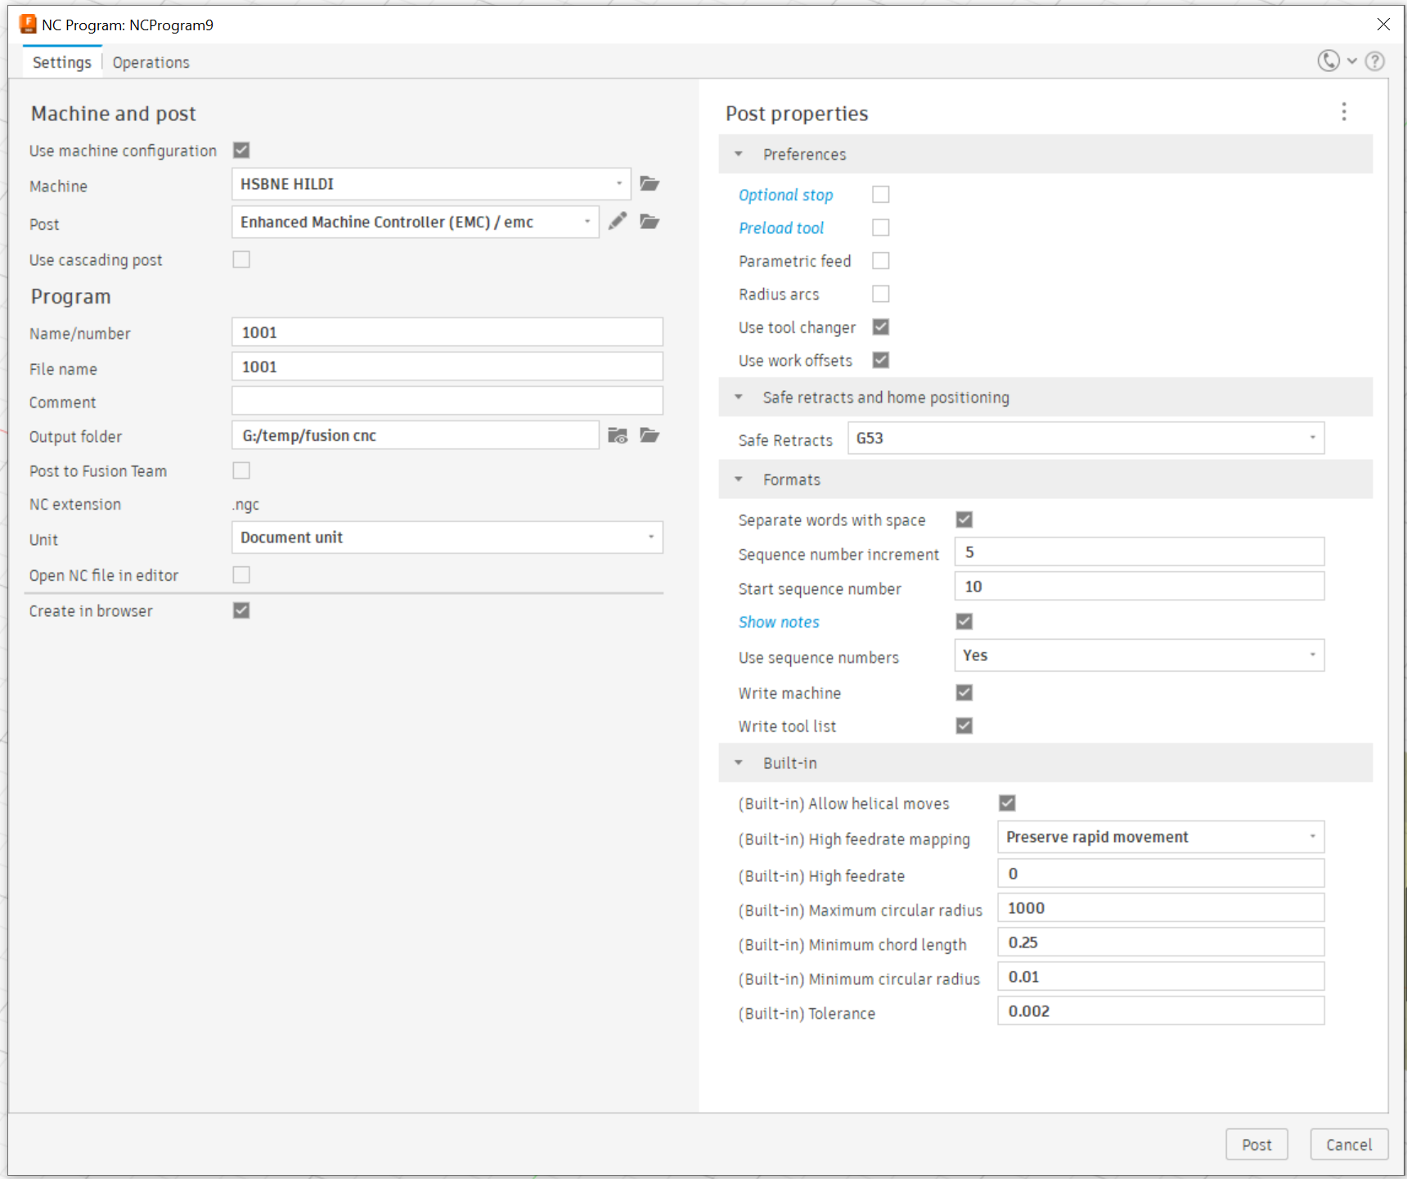
Notes:
- The settings above should be the default when using the HILDI post processor.
- It is good to do a generate of the setup before Post Processing.
- For information of the Post Properties see the NC program code samples reference.
- Ensure that Use tool changer is checked. This is needed to pause the program so that you can change the tool.
- Preload tool is not required and can be unchecked.

Setup Sheet
It is good to generate the setup sheet so that you know what lengths (below the holder) to set the tool to.

HILDI Operation

Power On
- Power on the machine from the switch at the back.
- Press the green button on the side of the control panel. This will boot Linux CNC.
  - Wait for Linux to load.

Load Program
- Insert the USB drive to the computer.
- Copy the program locally to the nc_files folder.
- Press the Fullscreen button.

Enable Motion
- To enable motion, press the ESTOP and ENABLE buttons.

Home all Axis
- Z
  - Press the Z button (to select Z as the active axis)
  - Press the HOME AXIS button.
- Y
  - Press the Y button
  - Press the HOME AXIS button.
- X
  - Press the X button
  - Press the HOME AXIS button.
- Note: You can perform these actions in quick succession with the HOME ALL button on the manual control tab of the GUI.

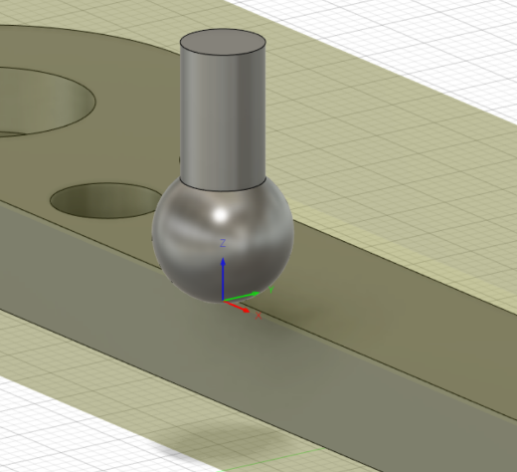
Set the G54 Work Offset
In this step we match up the origin point from the model with reality on the machine. In the example to the right you can see the origin point half way along the x axis. We need to touch off the very bottom tip of the probe to the X,Y,Z for this this point.

- Set the mode to G54
  - In the MDI tab run a G54 command. The coordinate display should show it in the G54 mode.
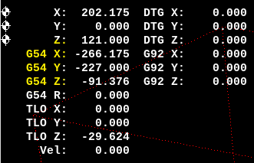
- Load the Probe Tool (tool 1) choosing Probe & Continue.
  - See appendix A on how to do this.
- X Axis
  - Jog the X axis to the origin point for that axis until the probe touches off (lights and buzzer). See Appendix B for jog instructions.
  - Press the TOOL OFFSET (Touch Off in GUI) button. If the touch off point is the side of the probe you need to account for its width by entering an offset of -5mm (when touching off the left side of the part.
- Y Axis is the same as X but the offset must be -5mm.
  - This is assuming the touch off point is the side of the probe and you are touching off a face that is closest to the front of the machine.
- Z Axis
  - Jog to the Z axis origin point (typically top of the stock) until the probe touches.
  - Press the TOOL OFFSET button and enter an offset of 0mm.
  - Note: if you want to do a test ‘air cut’ above the stock, then set the Z-origin well above the real point.

Set the Tool Offsets
For each tool in the program except the Face mill (Tool 2), the following procedure is required to set its Z offset:
- Ensure the tool is in the tool holder with the stick-out approximately as per the length setting in the setup sheet.
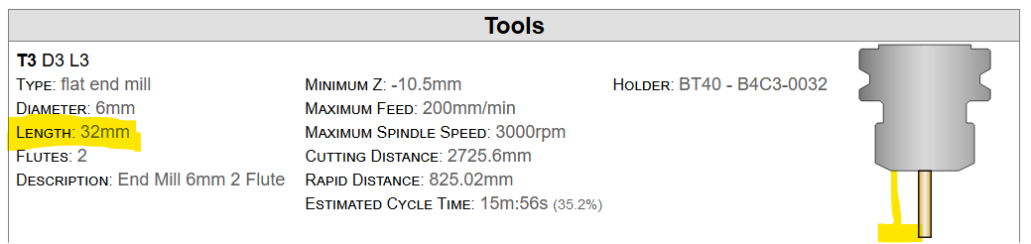
- Load the tool as per Appendix A and choose Probe & Continue. This will run through the tool height probe process and set its height offset in the tool table.
For the Face Mill (Tool 2):
- Load the tool and do not probe.
- Jog the tool to the G53 Z origin point (typically the top of the stock).
  - Note a piece of paper can be used below the tool so that the stock is not scratched.
  - Press the Z button then the TOOL TOUCH OFF button on the GUI (not a physical button).
  - Set the offset to 0mm.

Test Tool Offsets
This is an optional, but recommended, process to double check the tool offsets.
- Load a tool (probing not required as this has already been done).
- In the MDI tab run the following command: G54 G0 X0 Y0 Z 100. This will move the tool to 100mm above the G54 origin point. Ensure that reality meets expectation!

Run the Program
- Setup the coolant nozzles to a suitable location if needed.
- Load the program.
- Press the RUN button and the program will execute.
- For each tool change in the program, there is no need to probe the tool as the heights have already been set.

Notes while running:
- The E-Stop will only stop the spindle and not the XYZ motion. Use the STOP button instead!
- The COOLANT button can be used to turn on and off coolant manually.
- You can adjust the feed rate (Feed Override) using the 0-9 buttons. 0 = 100%, 9 = 90%, 8=80%, etc.

Clean-up
- Remove the tool.
- Clean up all chips on the table. Take them to the bin don’t just leave them on the bottom of the machine.
- Wipe down the inside of the door.
- Ensure that the probe is in slot 1 and the face mill is in slot 2.
- Remove any of your cutters from the tool holders.

Appendix A – How to load and unload a tool
To load a tool:
- In the right hand toolbar hit the button for the tool to load
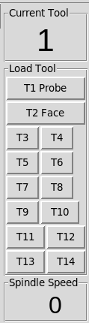
- The spindle will move to the tool change position and display the following prompt:
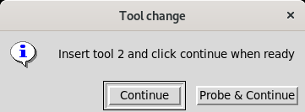
- Insert the tool into the spindle holding it as far up as possible.
- Press the white power drawbar button briefly until you hear the ratchet.
  - Note: Ensure that the tool has properly engaged with the spindle key.
- At the dialog. Choose Continue only if the tool height offset has already been set. Choose Probe & Continue otherwise to probe the tool and set its height offset. This will lower the tool onto the tool setter.
To Unload a tool:
- Ensure that the spindle is stopped and the machine is not moving.
- Grab the tool and press the black power drawbar button until the tool is released.
  - Note: If the power drawbar does not release the tool after 3 seconds, manually rotate the tool and try again. You sometimes need to find a good rotation where the drawbar works best. If this does not work the tool may be too hot and may need to cool down first.

Appendix B – How to Jog
To Jog ensure that you are in Manual Jog mode by pressing the Manual Jog button.
Rapid movements can be achieved by using the X-, X+, Y-, Y+, Z- and Z+ buttons on the control panel.
Fine movements can be used by the jog pendent:
- Set the Axis
- Set the Speed. X100 is generally not recommended.
- Hold down the white button on the side and rotate the jog wheel.
  - Important: Each click of the jog wheel is queued up for movement. If you rotate it too fast it may not stop where you expect it!

Appendix C – Linux CNC G/M-Code Reference
- G-Code
- M-Code
- O-Code

